3.02 How do you use your brain? Name_____________________
Handout Date______________________

Directions: Label the diagram with the appropriate functions of each area of the brain. Illustrate as needed to fit. Record class discussion in the space provided and on the back.
- cerebrum
Parietal lobe
________________________________________________________________________________________________________________________________________________________________
- diencephalon
- cerebellum
- brain stem
- limbic system

Frontal lobe
________________________________________________________________________________________________________________________________________________________________

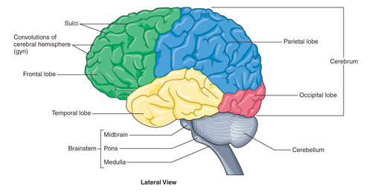
Temporal lobe
____________________________________________________________________________________________________
Brain stem
______________________________________________________________________
Occipital lobe
____________________________________________________________________________________________________
Cerebellum
____________________________________________________________________________________________________

Notes:
Diencephalon___________________________________________________________

Limbic system__________________________________________________________
________________________________________________________________________________________________________________________________________________________________________________________________________________________________________________________________________________________________________________________________________________________________________________________________________________________________________________________________________________________________________________________________________________________________________________

