2.01 Signs and Symbols Matching Name ________________
Handout Date _________________

Directions: Match the scenario given below with the sign that is appropriate for the situation described. Some scenarios may require more than one sign. Signs will be used more than once.

_______ 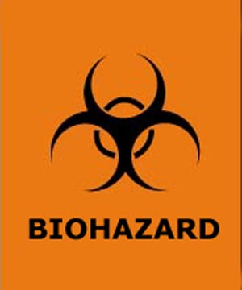

_______

_______ 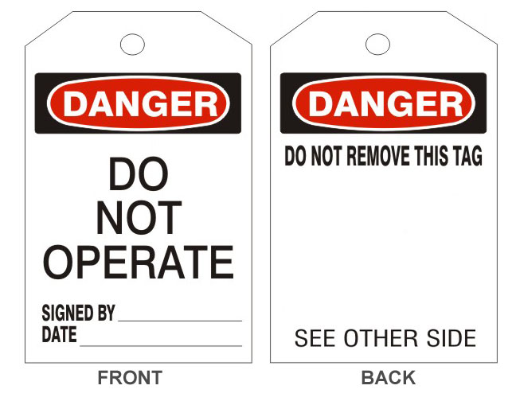

________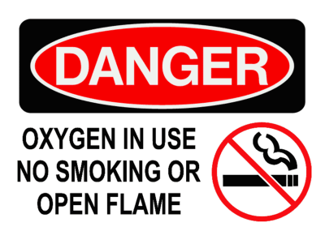

_________ 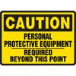

__________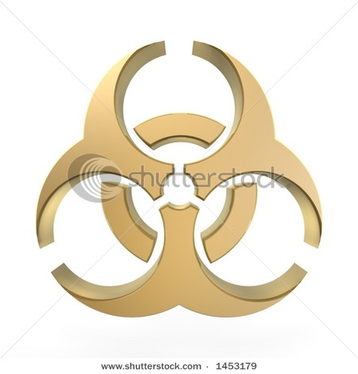

Frank was admitted to the hospital with fever, night sweats and productive sputum. He is placed in an isolation room.

- Lisa received multiple injuries in an automobile accident. She was admitted to the Intensive Care Unit following the surgery to repair her injuries.

- Jason works in the hospital’s housekeeping department. He regularly processes contaminated items. Which sign would Jason see?

- Molly found the exam room door closed. She was unable to enter the room because she did not have the proper apron to protect herself.

- If equipment is broken or damaged, Libby should find this sign attached.

- Brian needed to get Mr. Smith out of bed. Mr. Smith has a Staphylococcal infection of his lower leg. Brian found this sign on Mr. Smith’s door.

